Task 9.2

Isaac Pittolo – 7695438  
Hoang Linh Bui – 100017631  
Adam Bubonya – 9986677

# Software Design

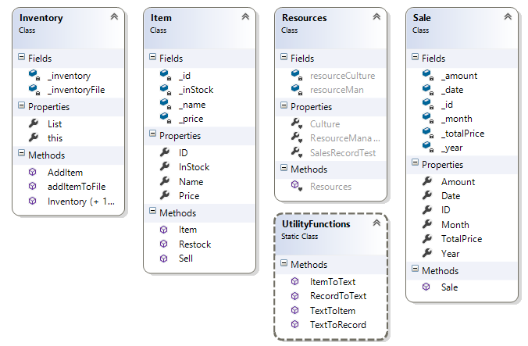

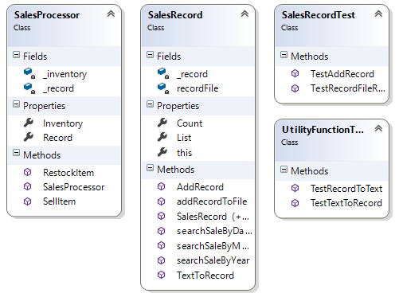

# UML Diagram

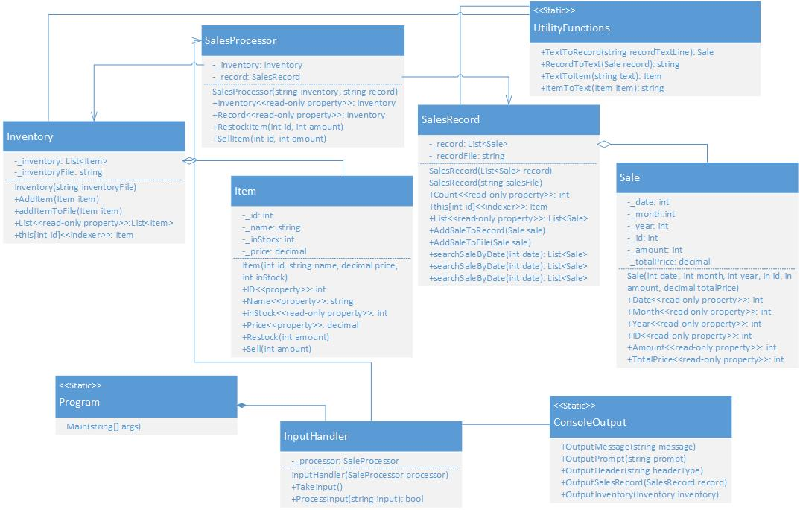

# Justifications

All our methods and subroutines are related to each class and not too relevant to other classes, thus having strong cohesion. For example, in our Item object, all of its values and any modifications are done internally. They are self-contained and shows a good use of the encapsulation principle.

There is little to no dependencies in our application. There are some associations such as between Sales and SalesRecord, or between Item and Inventory, which is required for some interactions, but the other objects are all very self-contained with weak couplings.

The only principle of Object-oriented programming that we implemented was Encapsulation. As for the other three, Inheritance, Abstraction and Polymorphism, we postpone on using them to avoid overcomplication, however, they will most likely be implemented later as the software is developed further.

Due to the lack of a database to work on and utilize, we used a set of .txt files to store information, and built a system to convert text format to data for the software. This method is simpler and does not rely on Internet connection, and thus improves the performance of the software, particularly the read/write speed.